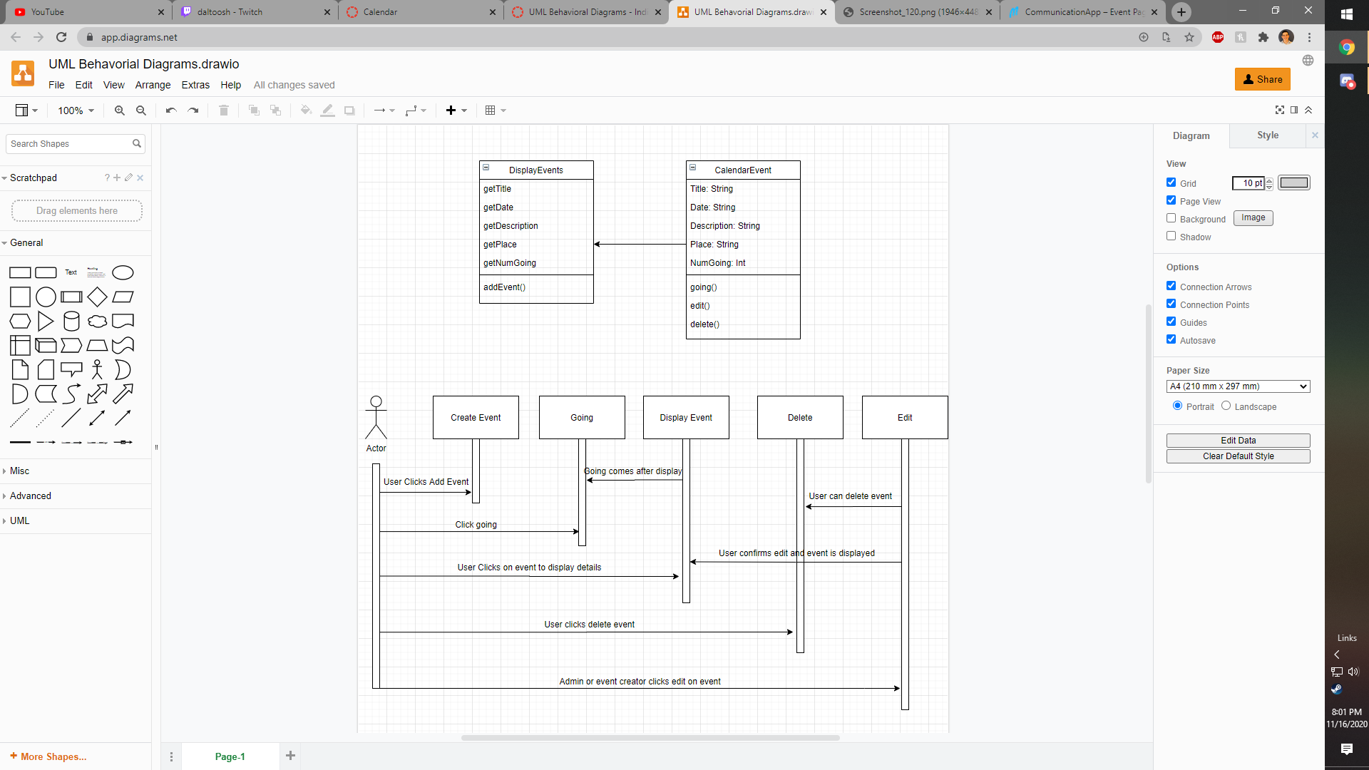

The calendar event class houses the information for the event that the user creates to put on the calendar. The calendar event class has methods to store if people are going, for user to edit, for user to delete. The display events class allows the events to be populated to the page and allows for the event to be created in the first place. This gets the info from the events to display them. The sequence diagram shows the process of the user completing the functions of the calendar events.